Ideation Phase
Define the Problem Statements

Date | 04 October 2026
Team ID | SWTID-2026-5690
Project Name | Implement Client Script & UI Policy (Incident)
Maximum Marks | 2 Marks

Customer Problem Statement Template:
Create a problem statement to understand your customer's point of view. The Customer Problem Statement template helps you focus on what matters to create experiences people will love.
A well-articulated customer problem statement allows you and your team to find the ideal solution for the challenges your customers face. Throughout the process, you’ll also be able to empathize with your customers, which helps you better understand how they perceive your product or service.
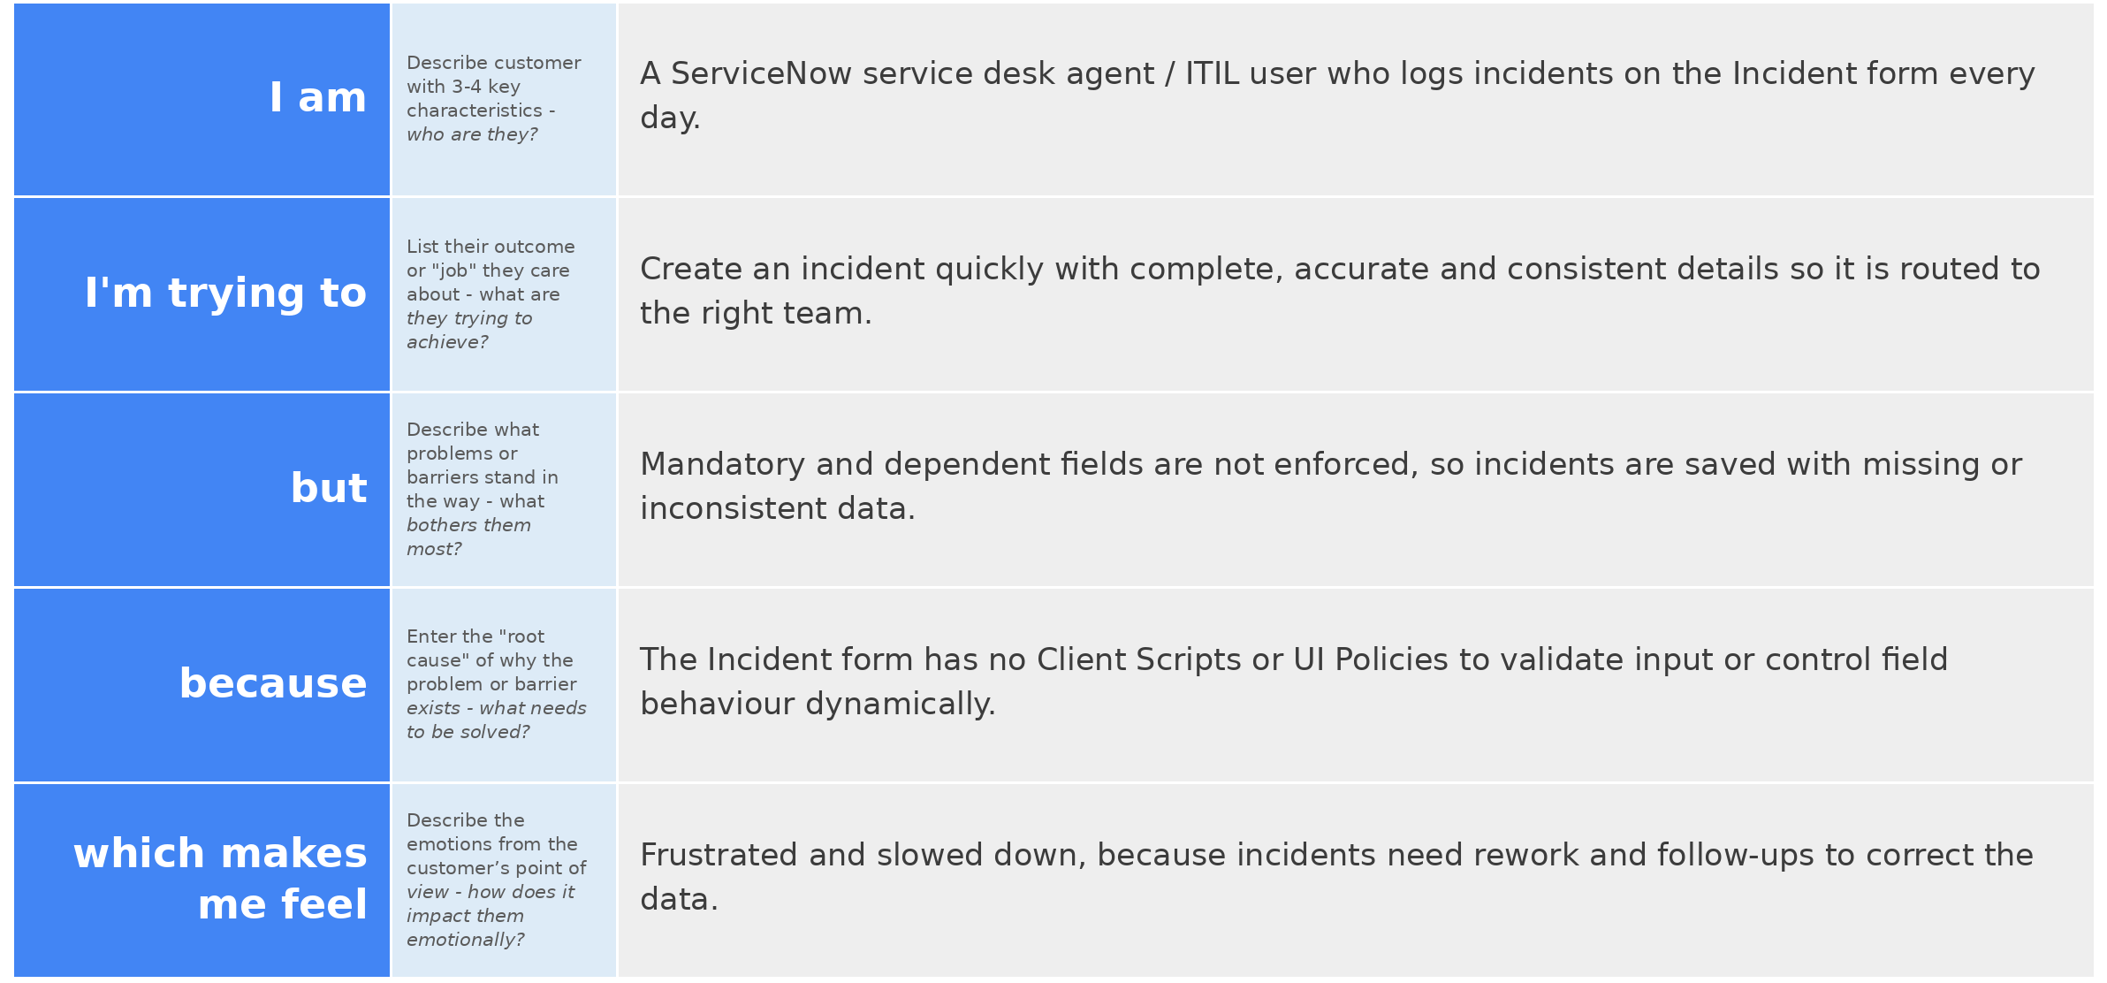
Reference: https://miro.com/templates/customer-problem-statement/
Example:

Problem Statement (PS) | I am (Customer) | I’m trying to | But | Because | Which makes me feel
PS-1 | A service desk agent / ITIL user who logs incidents in ServiceNow | Create an incident quickly with complete and accurate details | Mandatory and dependent fields are not enforced, so incidents are saved with missing or inconsistent data | The Incident form has no Client Scripts or UI Policies to validate input or control fields | Frustrated and slowed down by rework
PS-2 | A support analyst (resolver) who works and closes incidents | Resolve and close incidents with proper resolution details | Incidents can be closed without close notes, and unneeded fields clutter the form | Resolution fields are not shown or made mandatory based on State, and no checks run on submit | Overloaded and concerned about poor record quality

